CS 4379 Programming Project 3 Brief Report

Jacob Zahn

Professor Yong Chen, Computer Science, Texas Tech University

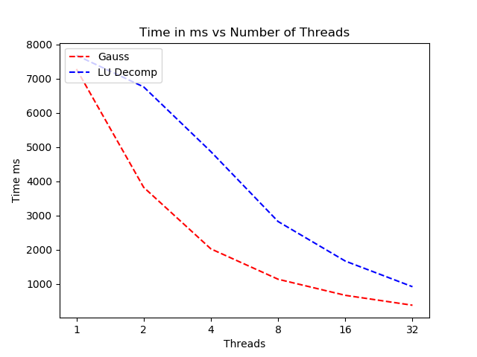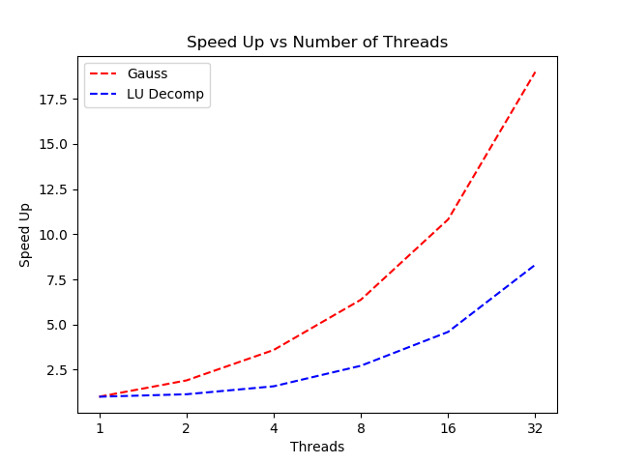

Above are the plots for Time in milliseconds and Speed Up from using more threads in gaussian elimination and LU decomposition to solve linear systems with N = 2000. Both methods offer sublinear speed up performance but Gaussian elimination with dynamic scheduling offers considerably higher Speed Ups as compared to column wise LU decomposition with in order scheduling. Quanah’s speed up numbers for the LU case are quite higher than those offered on my machine, although this may be a result of compiler and architecture differences. The speed up results for dynamically scheduled gaussian elimination are higher than my load balanced Pthread implementation of LU decomposition from last project. The dynamic scheduler is well implemented in OMP it would seem. These results point towards using the scheduler on non-load balanced work instead of rewriting the algorithm to balance the load.